Linear Algebra & Differential Equation
Project On

APPLICATIONS OF PCA IN IMAGE COMPRESSION

A Project Submitted
in Partial Fulfilment of the Requirements for the Degree of
Bachelor of Technology
in
CSE

SUBMITTED BY: GROUP NO: 6
Group Members:
Yug Saini
Vivek Raman
Parvesh Jangid
Siddhant Khatana


SCHOOL OF ENGINEERING AND TECHNOLOGY
BML MUNJAL UNIVERSITY GURGAON
December 2025

Contents

- Problem statement
- Introduction
- Materials and Method
- Results and discussions
- Conclusion
- Acknowledgement
- References

Problem Statement: -

In today’s world, data is everywhere and everything. All the tech giants around the world are racing against each other in this race of collecting data. High resolution photos captured by smartphones, CCTV systems, medical scanners, satellites, and social media platforms generate massive amounts of image data every second. In today’s world of Artificial Intelligence, about 34 million images are being generated by AI per day (in 2024). Imagine its growth according to 2025’s boom when companies like ChatGPT and Gemini are proving free AI images generation. Storing and transmitting this data now becomes are challenge, especially when 20,000 pictures are being uploaded on social media per second.
Cloud storage is constantly growing but not as fast as the world needs, therefore the prices are skyrocketing. There are two ways of solving this problem:
- Improving our Hardware: Research and development will take a lot of time and money.
- Improving our Software: This can be done simply by changing how we store our data.
Therefore, the question now comes to “How can we store images more efficiently without losing critical visual information?”. In this paper, we will explore how Principal Component Analysis works, and how we can use it to store images efficiently.

Introduction: -

Principal Component Analysis (PCA) is a fundamental dimensionality reduction technique used across data science, signal processing, and image analysis. At its core, PCA transforms high-dimensional, correlated data into a new coordinate system defined by orthogonal directions of maximum variance. These directions, called principal components, come from the eigen vectors of the covariance matrix, and their importance is calculated by their eigenvalues. In an image of let's say 512 x 512 pixels, data is stored in 512 rows and 512 columns (features). In this data, nearby feature’s pixel values are highly correlated with each other, PCA exploits this behavior and tries to find the value which best represents nearby pixels. Therefore, it turns multiple correlated values into one value which is uncorrelated to its neighbors. This allows the image to be represented in a lower number of columns while preserving the most dominant colors and features of the image. PCA is widely used in fields like image compression, noise reduction, and feature extraction.

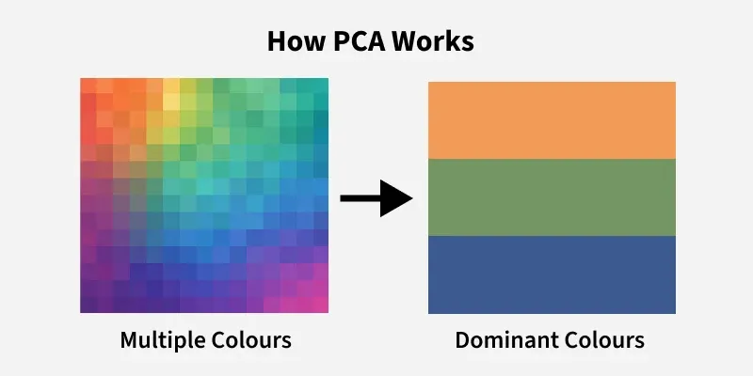Source: google

Step 1: Standardize the Data
Different features may have different units and scales. To compare them fairly, we normalize the data making each feature have:
- A mean of 0
- A standard deviation of 1

$Z=\frac{\left(X-μ\right)}{σ}$
where:
- μ is the mean of independent features $μ$=$\left\{μ_{1},μ_{2},μ_{3}….μ_{m}\right\}$
- σ is the standard deviation of independent features $σ=\left\{σ_{1},σ_{2},σ_{3}….σ_{m}\right\}$

Step 2: Calculate Covariance Matrix
Next, PCA calculates the covariance matrix to see how features relate to each other, whether they increase or decrease together. The covariance between two features x1 and x2 is:
$cov\left(x1,x2\right)=\frac{\sum_{i = 1}^{n}{​\left(x1_{i​}-\overline{x1}\right)\left(x2_{i}-\overline{x2}\right)}}{n-1}​$
Where:
- $\overline{​x1}$ and $\overline{​x2}$ are the mean values of features x1 and x2.
- n is the number of data points
The value of covariance can be positive, negative, or zero.

Step 3: Find the Principal Components
PCA identifies new axes where the data spreads out the most:
- 1st Principal Component (PC1): The direction of maximum variance (most spread).
- 2nd Principal Component (PC2): The next best direction, perpendicular to PC1 and so on.

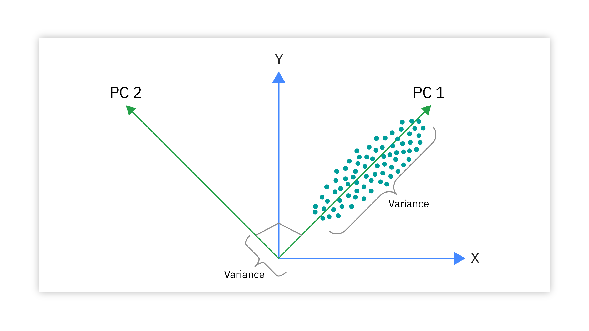
These directions, called principal components, come from the eigen vectors of the covariance matrix
A X = λ X
This means, when A matrix transformation is applied on X, it shrinks or stretches X by λ times.

Materials and Method: -

To implement PCA, we will take the following in use:
- Python Programming Language
- JuPyter notebook / environment
- Open CV library to read image files in Python.
- NumPy to perform numerical operations on large data.
- Scikit-Learn to implement PCA algorithm.
- Matplotlib to visualize images.
Before Starting, All this code is available in my Github, Click here
Step 01: Importing Libraries
First, we will import all these libraries into our python notebook main.ipynb
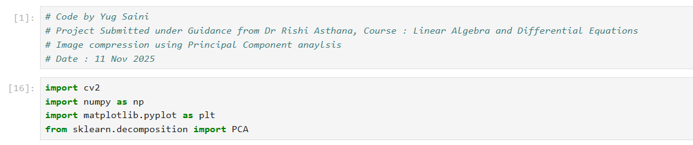
Step 02: Reading image into python using opencv:
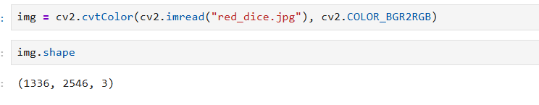
Here as the first image, we took an image of red dice sitting in a black background, since it has lots of constant coloring (black and red only), it will be easier to compress it into smaller dimensions while maintaining the accuracy. Here the cv.2cvtColor function converts our data which is being read by cv2.imread() function into R, G, B or red, green, blue values from BGR (default).
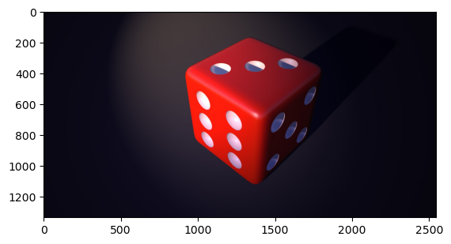
Step 03: Splitting into R, G, B and Normalizing values between 0 to 1:
These r,g,b values varies from 0 to 255, therefore by dividing them by 255, we can normalize to have values from 0 to 1.
Therefore, if we plot r, we will have
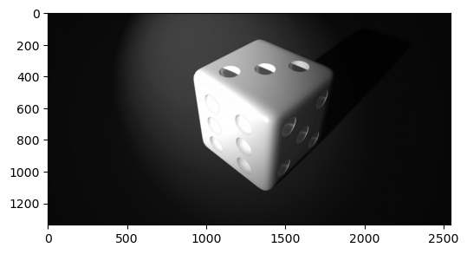
Here the brighter area means, in that region, red color is more dominant.
Similarly, on plotting g, we have the following.
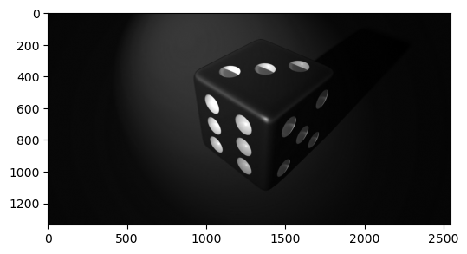

Similarly, on plotting b, we have the following.
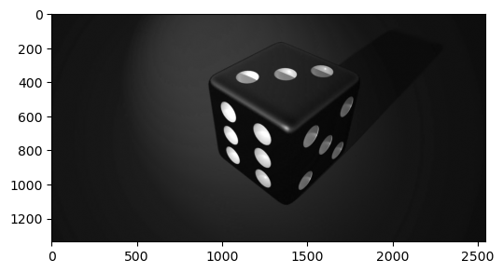
Again, bright regions mean, there is a presence of blue in that region.

Step 04: Applying Principal Component Analysis on our r, g, b data separately:
PCA was applied separately to the red, green, and blue matrices.
For each channel:
- The 2D image matrix was treated as a data matrix where PCA captures major intensity patterns.
- The number of principal components was fixed to 50 using
PCA(n_components = 50)

fit_transform() was used to compute the reduced representation of each channel.
This reduced representation contains the transformed pixel intensities with significantly fewer components, thus acting as a compressed version of the image.
Here if we check the dimensions of our data now, it has been reduced to (1336, 50) from (1336, 2546).
Step 05: Reconstructing r,g,b data and Combining:
To rebuild the original image from the compressed data:
- The PCA model for each channel is used to apply inverse_transform(), reconstructing the 2D channel matrices.
- The reconstructed red, green, and blue matrices are merged back into a single RGB image using cv2.merge().
reconstructed_r = pca_r.inverse_transform(reduced_r)
reconstructed_g = pca_g.inverse_transform(reduced_g)
reconstructed_b = pca_b.inverse_transform(reduced_b)

Therefore, we can turn this into a simple function, which will take images and k (number of components i.e. number of dimensions that you want to reduce to) as input and return reconstructed/reduced image made using PCA.
def pca_im(img, k):
img = img/255.0 r, g, b = cv2.split(img) pca_components = k pca_r =PCA(n_components = pca_components) reduced_r = pca_r.fit_transform(r) pca_g =PCA(n_components = pca_components) reduced_g = pca_g.fit_transform(g) pca_b =PCA(n_components = pca_components) reduced_b = pca_b.fit_transform(b) reconstructed_r = pca_r.inverse_transform(reduced_r) reconstructed_g = pca_g.inverse_transform(reduced_g) reconstructed_b = pca_b.inverse_transform(reduced_b) img_reconstructed = (cv2.merge((reconstructed_r,reconstructed_g,reconstructed_b))) return img_reconstructed

Results of Simulations: -

Depending on the complexity of images, the value of n_components (or k) varies. For example, on the image of red dice with black background, even a value low as k = 50, reproduces a clear image as original one.
When k = 50
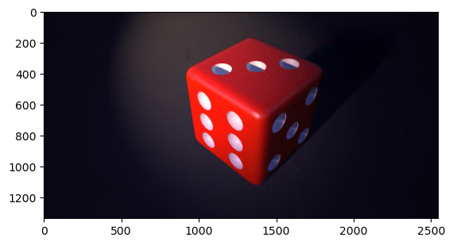
Whereas when k = 25, the image looks little bit diminished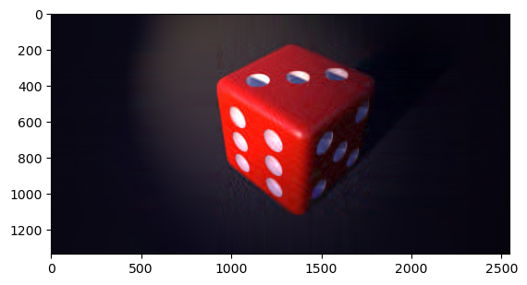
Let's take an image of a dog, which is textured and run PCA on it, which is slightly more complex than a red dice.

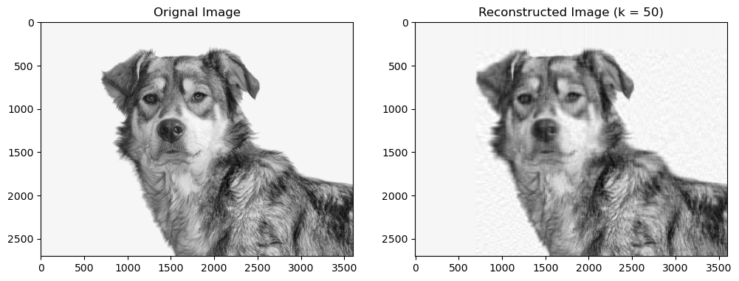

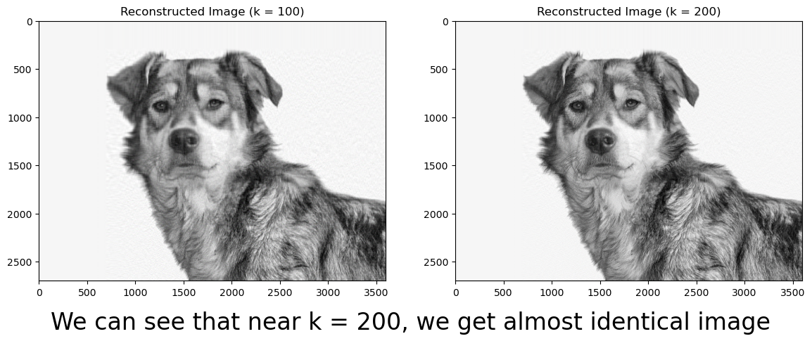

We can see that, near k = 200, we get almost identical image (in looking) as the original one without any noise like in k = 100.

Now let's take an image of a squirrel which has more colors and features than previous pictures.
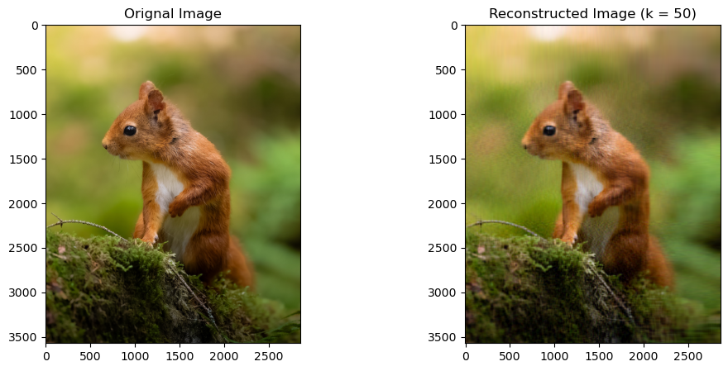
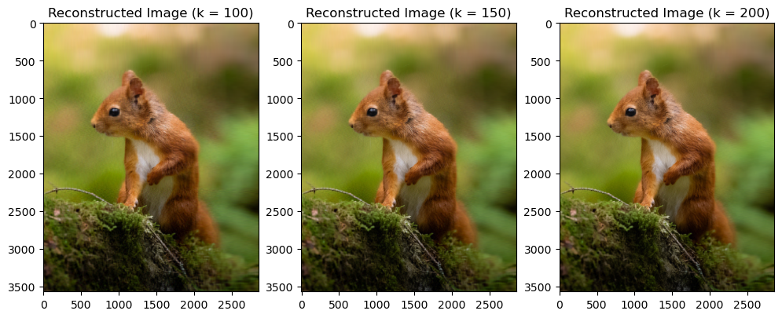
Again, around k = 150, we get an image which accurately maintains the features of the original image.

Now, let's take a look at pictures which are full of colors and consist of various features.
This image has a dimension of (3991, 5588, 3), about twice the columns of the red dice.
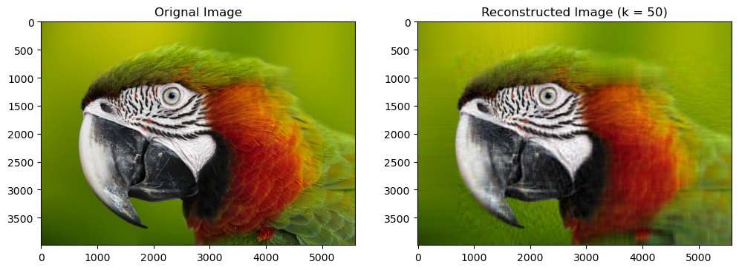
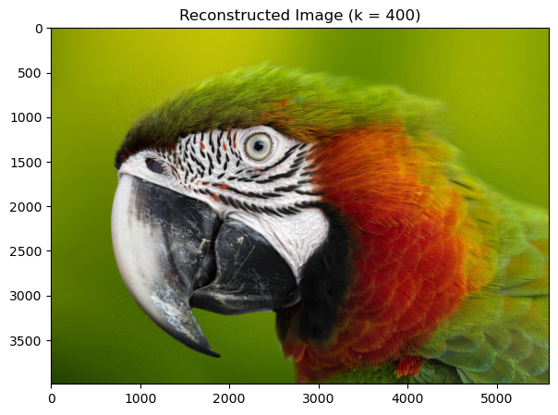
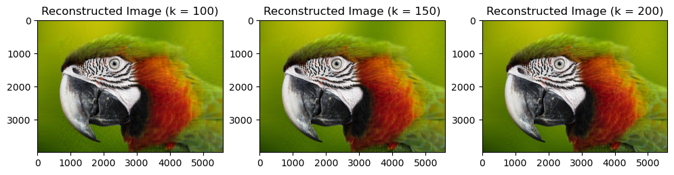

Here, we can still see some blur effect near bottom left edge and top right edges of the picture.

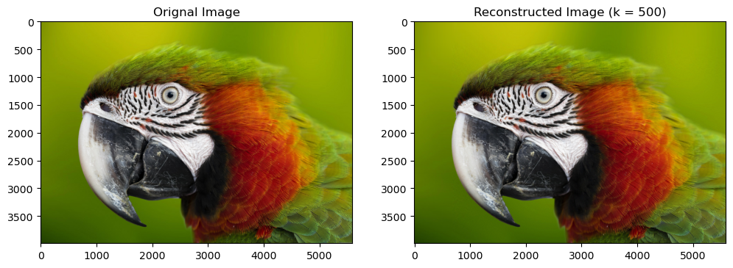

But when k = 500, we can see that our reconstructed image retains all the important features of the original image and produces an identical replica of it. This new reconstructed image has even enhanced blur effect and sharp edges as compared to original image.

Conclusions: -

PCA has various applications in image compression:

- Size Reduction: The reconstructed images require storing only fewer values, therefore its storage size decreases.

- Noice Reduction: In this last image of macaw, we can see that the blur effect is enhanced, which makes the reconstructed image even better than the original image.

- Faster Image Transmission: While the image is still reduced (k columns), we can transfer data in this form and reconstruct it anywhere we need. Therefore, this method of data transmission makes this task quicker.

- Feature Extraction for Machine Learning: Even though the main task is compression, PCA-compressed images keep the important features, therefore making the difference in accuracy negligible while making the models train faster since the data is less.

- PCA is widely used in MRI / CT scans, satellite and hyperspectral images, because these images have multiple channels, PCA efficiently compresses them with minimal loss of quality.

In conclusion, in this paper, we have explored how PCA is used in image compression and various fields it is used in. We discussed it with different examples involving images of differing complexities in their color schemes.

Acknowledgement: -

We would like to express our sincere gratitude to our course professor, Dr Rishi Asthana, for their continuous guidance and support throughout this project. Their insights into Linear Algebra and PCA greatly helped us understand the mathematical concepts behind image compression. We also extend our thanks to our Python instructors, Prof Harsh Taneja and Prof Anantha Rao, whose teaching and practical sessions enabled us to implement the algorithms effectively using python. Their combined support, encouragement, and feedback were instrumental in the successful completion of this project.

Reference: -

1. NumPy
Harris, C. R., Millman, K. J., van der Walt, S. J., et al. (2020). Array programming with NumPy. Nature, 585, 357–362.
Available at: https://numpy.org/
2. Matplotlib
Hunter, J. D. (2007). Matplotlib: A 2D graphics environment. Computing in Science & Engineering, 9(3), 90–95.
Available at: https://matplotlib.org/
3. scikit-learn (PCA implementation)
Pedregosa, F., Varoquaux, G., Gramfort, A., et al. (2011). Scikit-learn: Machine learning in Python. Journal of Machine Learning Research, 12, 2825–2830.
Available at: https://scikit-learn.org/
4. OpenCV
Bradski, G. (2000). The OpenCV Library. Dr. Dobb’s Journal of Software Tools.
Available at: https://opencv.org/
5. Python (general)
Python Software Foundation. (2024). Python Programming Language.
Available at: https://www.python.org/
6. Linear Algebra
D. Poole, Linear Algebra: A Modern Introduction, 4th Edition, ISBN-13: 978-1-285-46324-7, Cengage Learning, 2015.

News Article
Article-2

